How to add speed camera warnings to the New Porsche PCM 4.0 fitted in the 991.2

Requirements Porsche Connect
Registered to the Porsche connect Portal

Porsche Connect Portal

Log on to Porsche connect portal

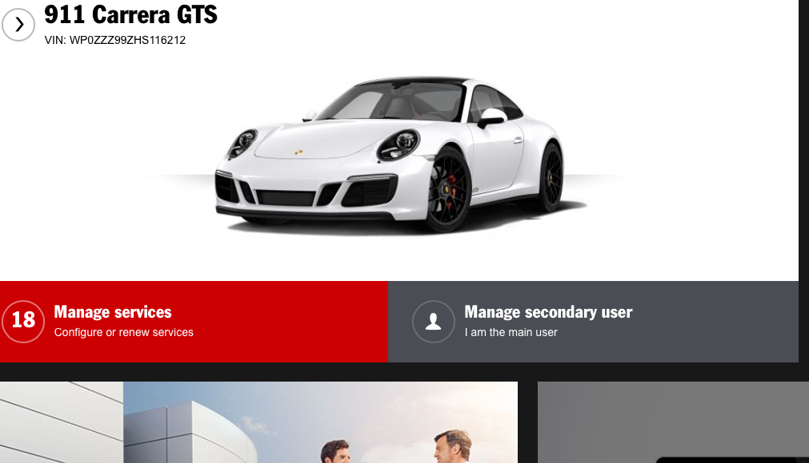

Select manage services

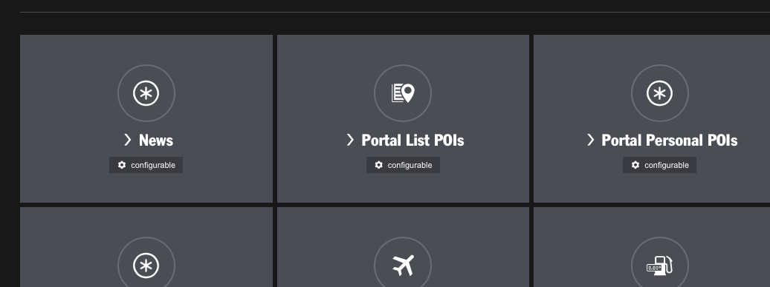

Select Portal List POI’s

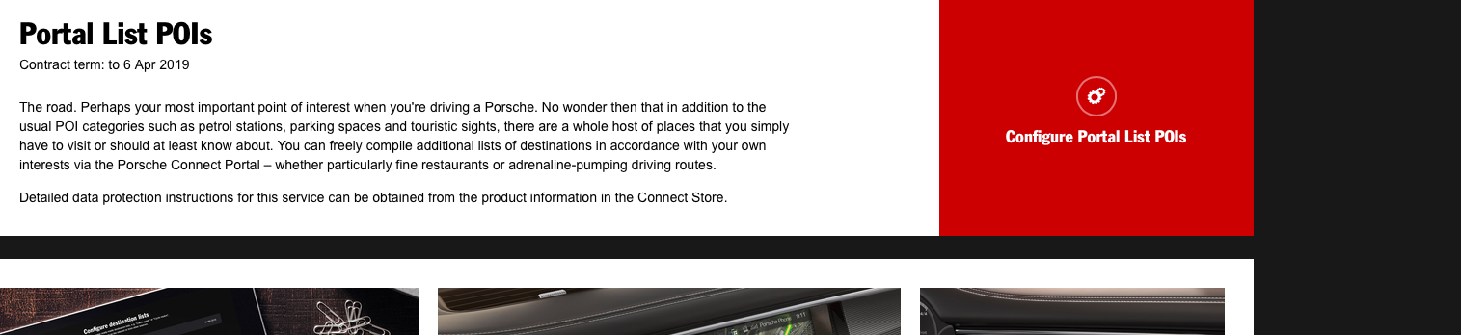

Configure Portal list POI’s

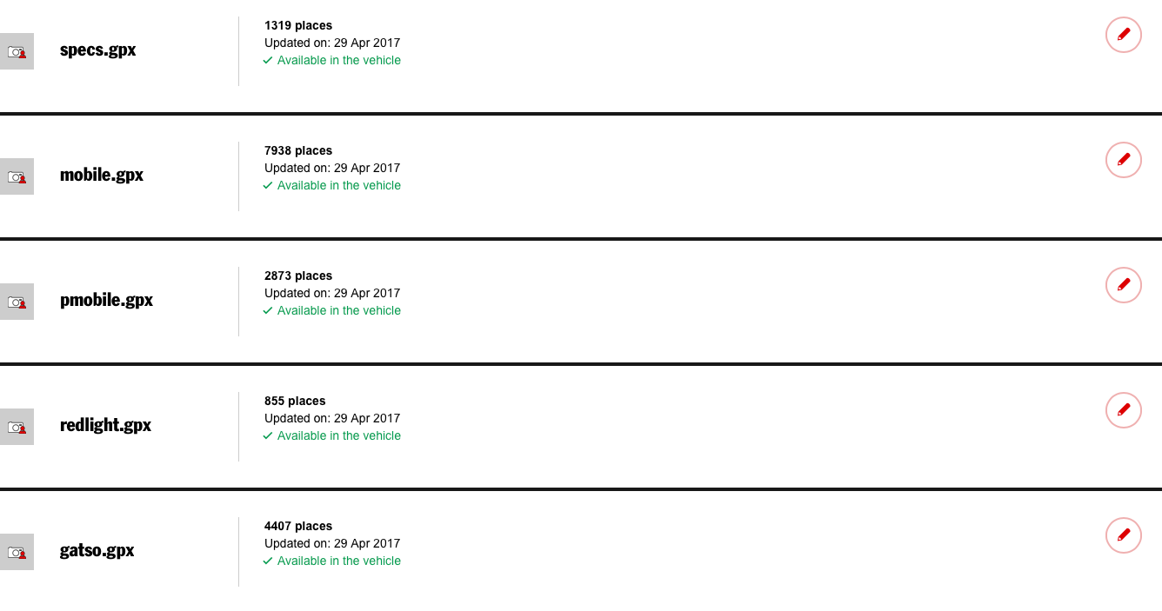
Select upload destination list
Browse and select the 5 files below from the drop box list
https://www.dropbox.com/sh/yiwrfqssw1z5031/AACnOeS0w-JJPQdOzYfbTQTca?dl=0

Once they are downloaded to your Portal they can be updated to your vehicle by selecting update destination list to vehicle.

Select available in Vehicle. I have selected the camera icon to display on the PCM.

Configuring the PCM in the car

- Press Nav
- Select POI
- Search nearby
- Select Portal List POI
- Select Update list
- Select online update
- Select portal point of interest
- When the file has loaded, Press start to update
- This will have to be done 5 times to include the 5 GPX files

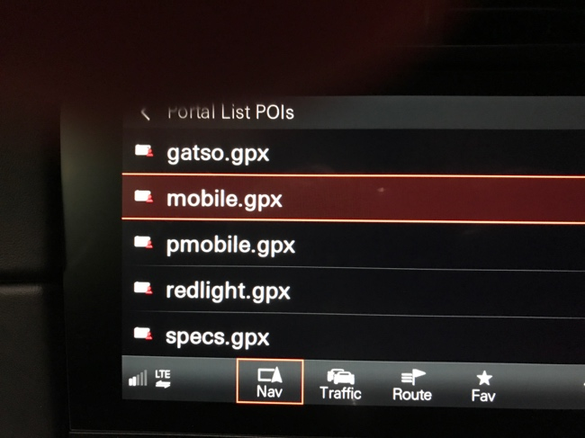
If there is no Portal list POI showing
Select
- Nav
- Opt
- Set Nav
- Navigation database Update
- Online update.

- 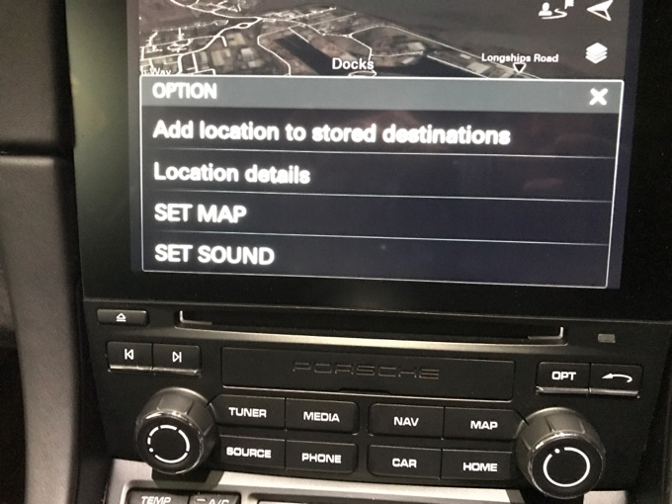

- Select Set map

- 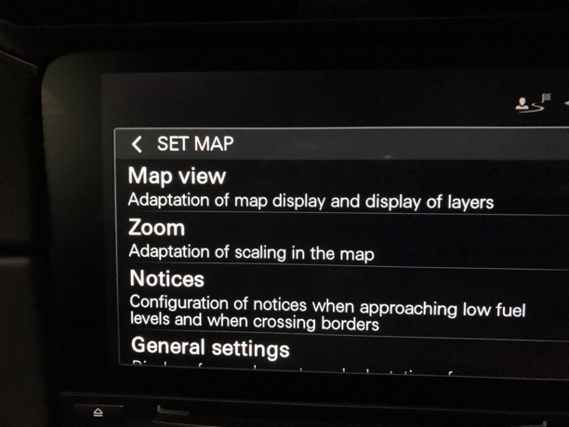

- Select Notices

- 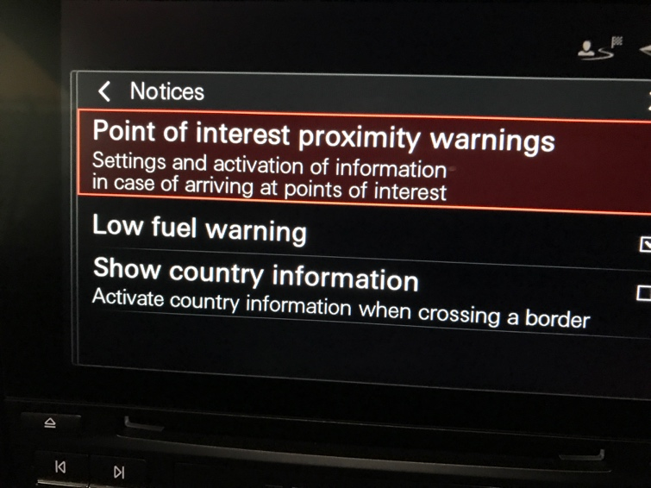

- Select point of interest proximity warnings

- 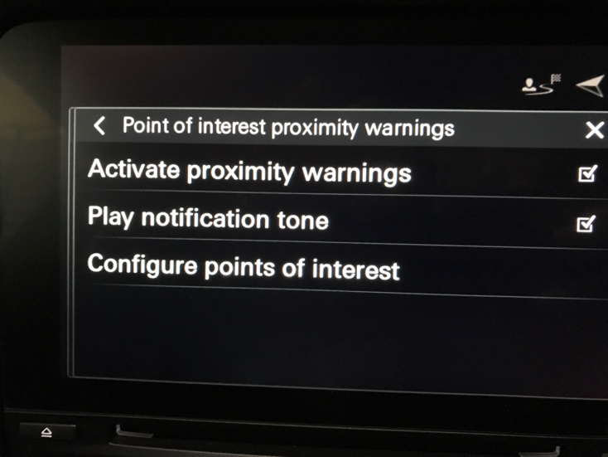

- Ensure the point of interest proximity warnings are checked as above.

- 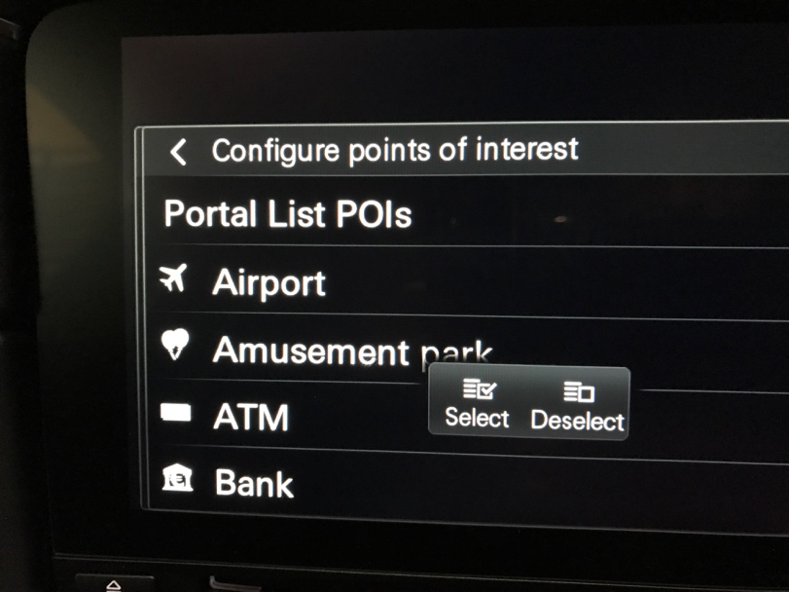

- Select Portal List POI’s

- 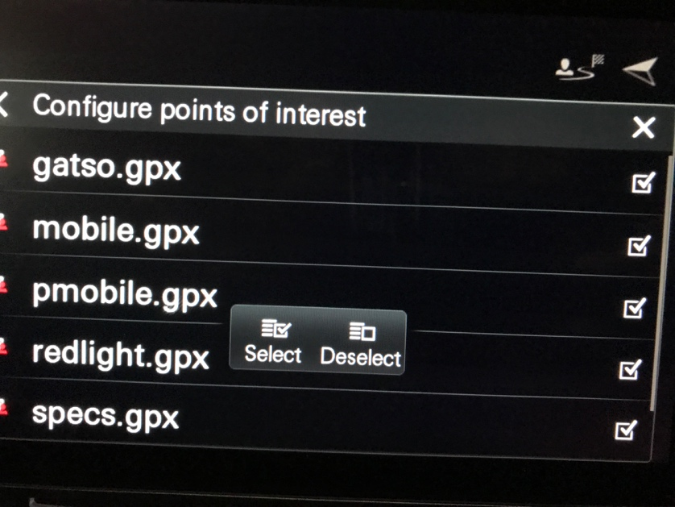

- Ensure that each camera GPX files are checked, otherwise there will be no warning.

Once the cameras are uploaded to the PCM, the cameras should appear as a camera icon on the display. All the icons will appear the same for each type of camera. There will also be an audio bleep.

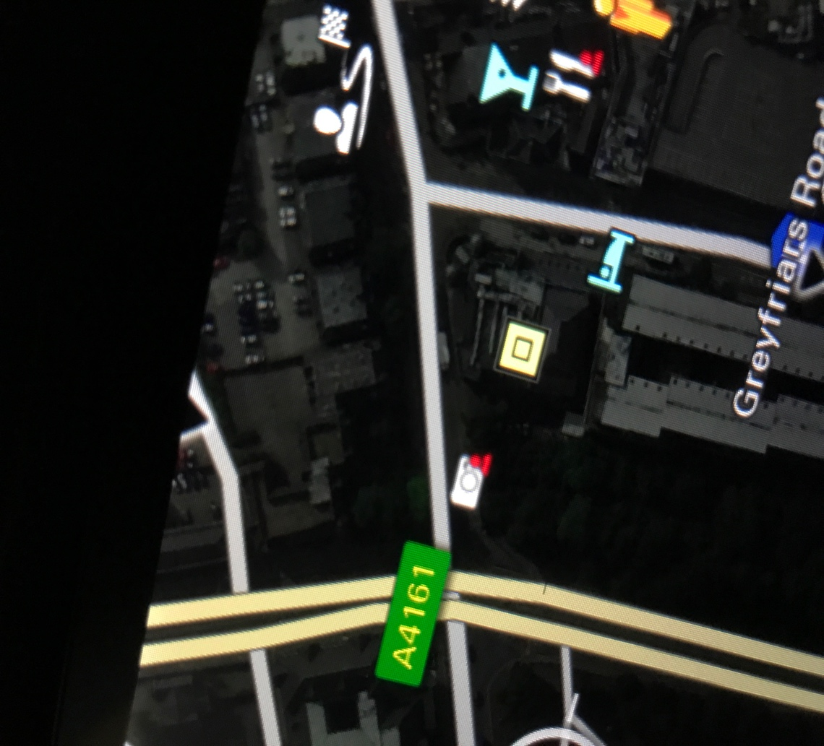

How the camera warning appears on the PCM. There will also be txt appearing on the top line of the PCM indicating what type of camera it is.

Please note. The camera database was updated in April. Any further update you will have to be updated from the web.

