28th January Mumbles Drive instructions.
37.4 Miles. 1hr 32minutes.

Starting location Junction 47 Moto Swansea West SA4 9GT 10:30

- Follow The A483
- At the roundabout take the 2nd turning for A484 Llanelli
- At the next roundabout take the 2nd turning A484 Llanelli
- At the roundabout take the 1st turning for B4295 for Gowerton
- After the railway bridge turn right for B4295
- 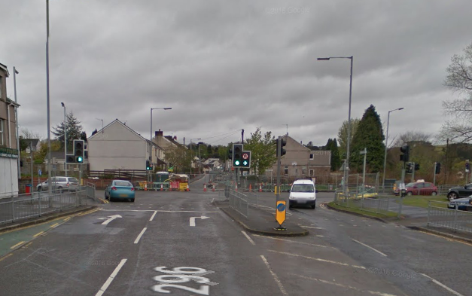

- Keep on the B4245 through Penclawdd , passed Llanidian, towards Oldwalls

- At Oldwalls turn right for Llanmadoc
- 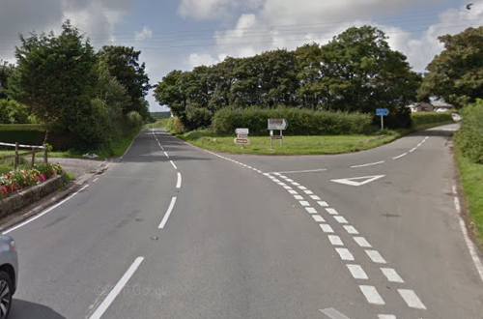

- Keep on road passed Bridge Pottery LHS at Cheriton
- At Llanmadoc turn sharp left for Llangennith
- 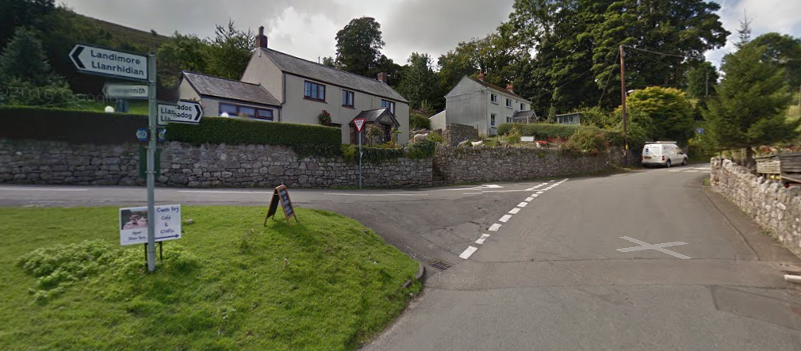

- After a cattle grid turn right for Llangenith
- At LLangenith follow the road towards the Beach
- At the small mini roundabout turn left for Moor lane
- At the end of the lane we come to Hill end caravan Park for a break at Eddy Restaurant.

Suggest no more than 30 minutes here.

- Follow the same route back, instead of turning for Llanmadoc, remain on this road until Burry Green
- At Burry Green turn right onto a small lane for Burry and Llanddewi. (Be careful this turning can be easily missed)

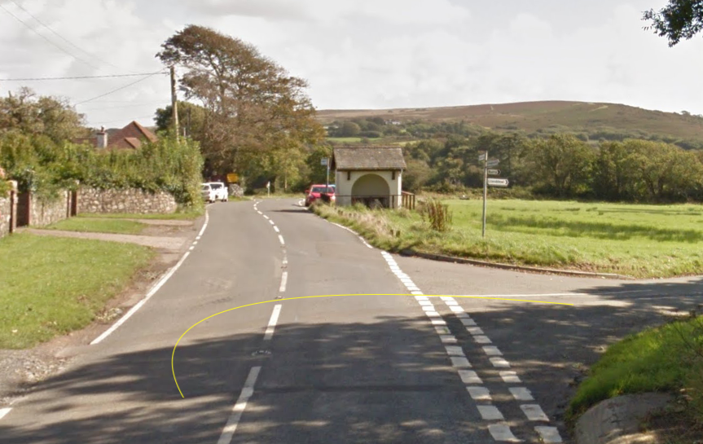
- Keep left at the fork for Fairy Hill and Reynoldston
- After passing the post office on the RHS turn left onto the Llanrhidian Road
- After driving over the moors turn left for B4271 Swansea
- Turn right onto to a small road for Lunnon. Can be easily missed
- 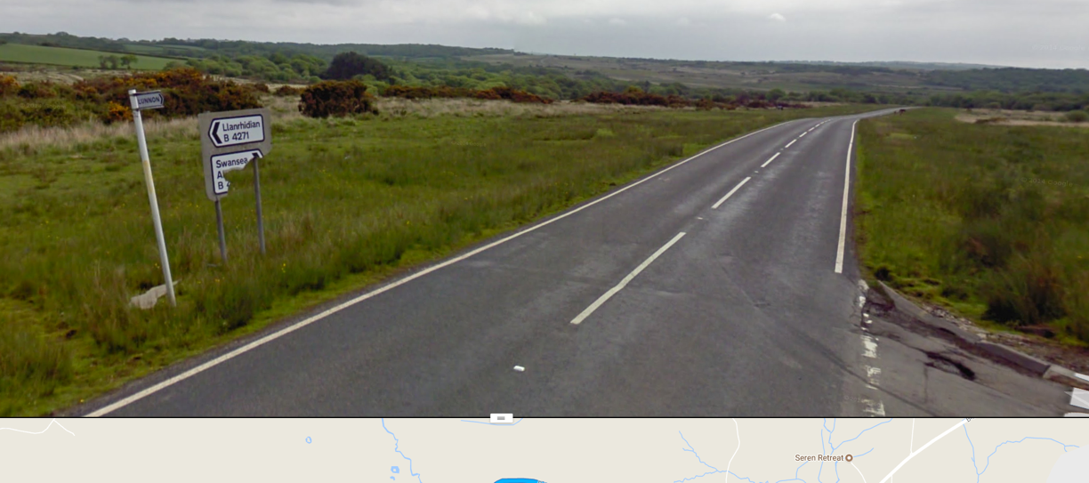

- Carry on this narrow lane until turning Left for the A4118 Swansea
- Remain on the A4118 until turning right for the B4436 Pennard and Caswell

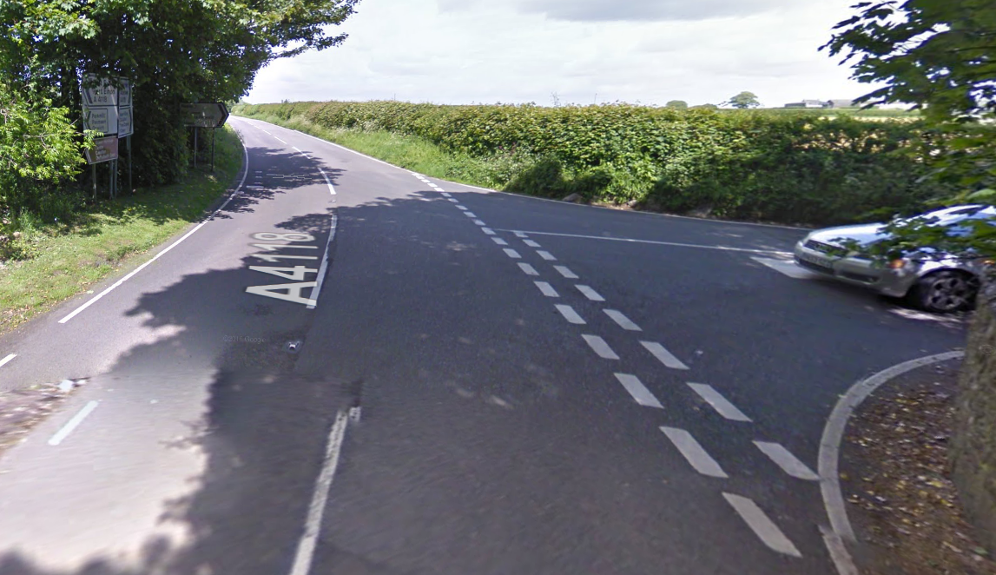

- At the junction of Pennard Road turn left for Swansea B4436
- Turn right at the traffic lights for the Mumbles Road
- Carry on the mumbles road until the car park of the Castellmare Restaurant Braclet Bay on the LHS SA3 4JT

Please note
The car park charges are £3 for 2 hours.

