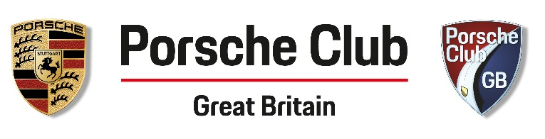
R8 Concours Entry Form
Porsche Pageant - Cromford Meadows Sunday June 27th
All prizes kindly donated by Porsche Centre Nottingham

Please select appropriate class:

Class 1: Region 8 air cooled cars.
Class 2: Region 8 water cooled cars.
Class 3: All visitors’ cars (non R8 members).

Class 1 and 2 will compete for Regional Champion. Prizes and rosettes to 3rd place in each class.

Entry for concours cars from 9.30am. Pay the £5 entrance on arrival; inform the staff you are a competitor because you will be parked separately. Car Preparation will cease at 11.15am for judging to commence. Prize giving and raffle at 2pm. We hope you have a great day.

Please print clearly

Name ……………………………………………
Address ……………………………………………………………………………………………
Porsche model ………………………… Colour ………………………………………
Year of manufacture …………… Reg. number ………………

You enter this competition knowing it be just for fun, all judging is subjective, carried out by a group of Porsche Club members with good knowledge of car preparation. The system is very similar if not the same to PCGB national judging methods. Available here. You must be at your car during judging. The judge’s decision is final. With thanks.

Signed ………………………………………….

Return this completed form to Tom Fisher 77 Nottingham Road, Trowell, Nottingham NG9 3PJ. Or scan copy to fishers911@aol.com

