R19 Event Update
Phyllis Tuckwell Motor Show, Churt - 11th August
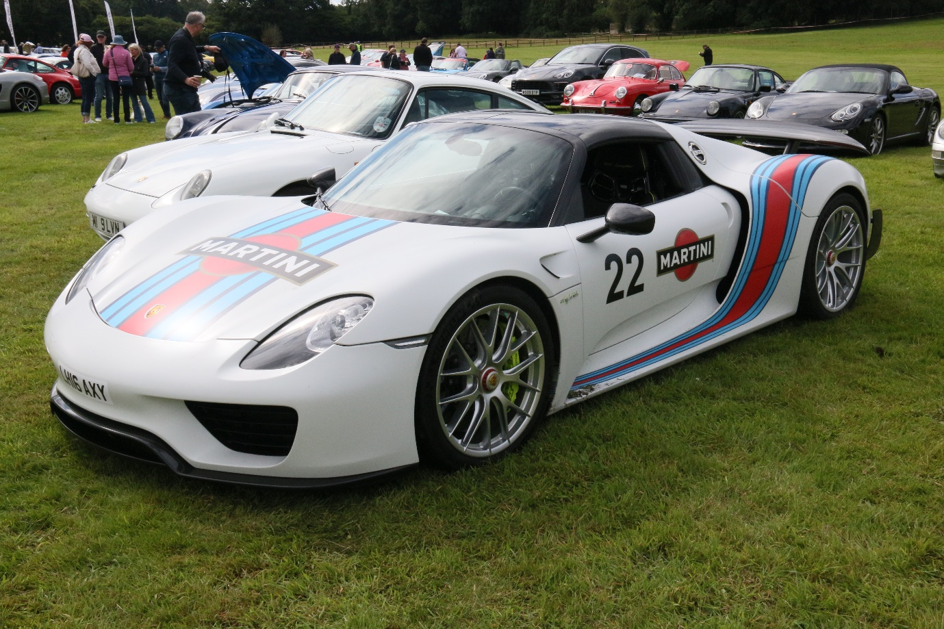
In spite of horrendous weather the day before this event last year, it was still a resounding success. All proceeds from the event are donated to the Phyllis Tuckwell Hospice in Farnham.
Not only do you get a chance to see all the vehicles on display but you also have the opportunity to wander around the Lewis collection and be amazed by the extraordinary vehicles on display.
Robert and Tanya Lewis have kindly given their paddock space again for the parking, this worked really well last year and in spite of the previous days’ rain was surprising dry and firm.
Tickets are £25.00 per car, an absolute steal considering what is on offer.

