DRIVER DECLARATION AND INDEMNITY - PART 1 VENUE: DATE:

I wish to drive cars and/or otherwise participate in the above event at the venue and date shown above.
I understand that motor sport is hazardous, and I am voluntarily exposing myself to risk of damage or loss or personal injury by participating in the event. Despite this I understand that racing is prohibited and that the purpose of the day is to allow the participants to enjoy themselves, improve their skills and learn the handling and braking characteristics of the cars which they are using.
I understand that any insurance carried by Porsche Club Motorsport Ltd and/or the circuit in respect of any liability which might arise out of the event will be limited and that my own motor third party and public liability insurance (if any) may not cover me for my losses, liabilities or personal injury arising on the day. I understand that Porsche Club Motorsport Ltd has strongly advised me to satisfy myself and my and my vehicle’s insurance cover on track and I am aware that specialist trackday insurance is available.

I understand the following:

- The circuit’s responsibility is to provide the venue, track, marshals and first aid cover.
- Porsche Club Motorsport Ltd will not be scrutineering participants’ cars before permitting them on the track; it has only limited control over the level of competence of other participants.
- Activity safety and participant discipline is not the responsibility of Porsche Club Motorsport Ltd.
- I am responsible for the way in which I use the track and for wearing appropriate protective clothing.
- That the circuit reserves the right to remove me from any of its events, at any time, if they consider my actions to be dangerous or detrimental to other circuit users.
- If I cause any damage to the circuit, paddock, circuit equipment, or barriers, I may be required to cover the costs.

I declare:
- That I am fit and healthy and that my eyesight (with lenses if to be worn) is adequate for track use.
- That any car for which I am responsible, and which will be used on the track is in good and suitable mechanical condition.
- That I am an experienced car driver.
- That I will not participate in the track day whilst under the influence of alcohol or intoxicating drugs.
- That I will comply with any and all rules set by the circuit and/or Porsche Club Motorsport Ltd.
I agree to make no claim against Porsche Club Motorsport Ltd that they should have taken responsibility for the matters set out in paragraphs 2 - 5 above which I accept are not their responsibility and to indemnify them against their costs and losses arising out of a claim made against them by anyone to the extent that such costs and losses are attributable directly or indirectly to my participation in the event. Should I bring such a claim and fail I agree to be responsible for the circuit’s defence costs on a full indemnity basis.

I have read and agree with the above Declaration and Indemnity and confirm that by signing this form, I accept the risks involved in my taking part in this event, and understood I have no grounds to claim off Porsche Club Motorsport Ltd or any associated companies. I understand that all food and drink provided free of charge by Porsche Club Motorsport Ltd is consumed by me at my own risk. I also understand that other food and drink is also provided by the circuit owner.

Re: Track Driving Instruction - Indemnity Part 2 (Please tick box to confirm acceptance)

I hereby agree and accept the following: -
There may be drivers present at Track Days who provide advice and assistance to other drivers. The Porsche Club Motorsport Ltd accepts no responsibility for the actions of such persons and cannot vouch for their experience or ability, either as a driver or as an advisor or ‘instructor’. Any driver taking the advice of such another driver does so at his/her own risk and should satisfy themselves of the capability of such driver before going on to the track accompanied by them.
The Porsche Club Motorsport Ltd does not carry insurance for your car to be driven by others and any decision to allow others to drive your car is yours alone.

Signed: ____________________________________________________________ (Club Membership Number) ______________

Print Name: ____________________________________________________________

Date: ____________________________________________________________

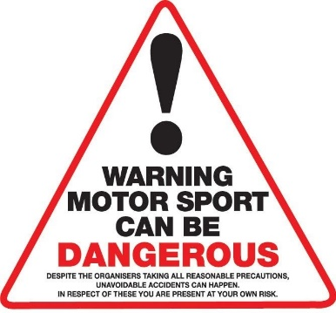
Name of next of kin/emergency contact:

Name: ____________________________________________________________

Address: ____________________________________________________________

____________________________________________________________

Tel: ____________________________________________________________

Attended briefing given by: _________________________________________________

Briefer signature: __________________________________________________________

PASSENGER INDEMNITY FORM VENUE: DATE:

I hereby agree and accept the following: -

In attending or participating in today’s event as a passenger I acknowledge that while it is neither a competitive event nor is racing permitted, nevertheless vehicles will be driven at high speed in a sporting environment. I acknowledge that in such circumstances and notwithstanding Porsche Club Great Britain, their servants and agents, and the proprietors of the circuit or venue taking all reasonable precautions, nevertheless accidents can happen. These notwithstanding, my attendance at this event shall be entirely at my own risk

I acknowledge that the Porsche Club Motorsport Ltd accepts no responsibility for the actions of any persons with whom I may travel as a passenger and that they cannot vouch for their experience or ability and that I should satisfy myself of the capability of such driver before going on the track accompanied by them.

Note to all participants.

At all times we must refer to the Track Indemnity Form signed by you and would highlight the fact that you are participating in an event at your own risk. As such any consequence / damage resulting from that participation must be borne by yourself.

Print Name: __________________________________________________
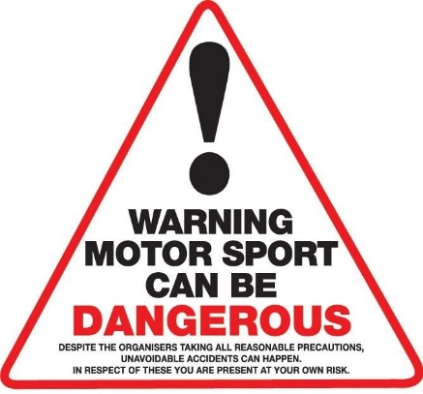
Signed: ______________________________________________________

Address: ______________________________________________________

______________________________________________________

______________________________________________________

______________________________________________________

Club Membership Number if applicable: ______________________

Date: ____________

18.02.21 PG

