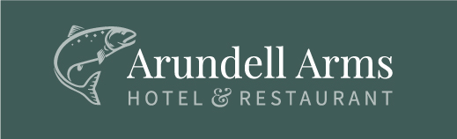

Porsche Club Dinner
7th August 2019

The Menu
Seared Brixham Scallops, smoked bacon and mushroom puree
Chicken Liver Parfait, red onion marmalade and toasted brioche
Mozzarella and Dried Tomato Salad, balsamic and basil
~~
Roasted Duck Breast, Confit Duck Leg, Lyd Valley asparagus and a peppercorn sauce

Best End of Lamb, wild mushrooms, peas, truffle mash and a cider jus

Mixed Grill of Sea Fish with tossed leaf salad, chips and a herb butter

Spinach, Tomato and Garlic Risotto with baby vegetables, parsnip crisps and parmesan shavings

~~

Dark Chocolate Terrine, honeycombe and coffee ice cream

Rhubarb Parfait, lemon curd and toasted walnuts

A Selection of English Farmhouse Cheeses with crackers, celery and grapes

Coffee and Chocolates
£34.00pp

