**PCGB SW Region**

**Porsche Silverstone Experience Raffle**

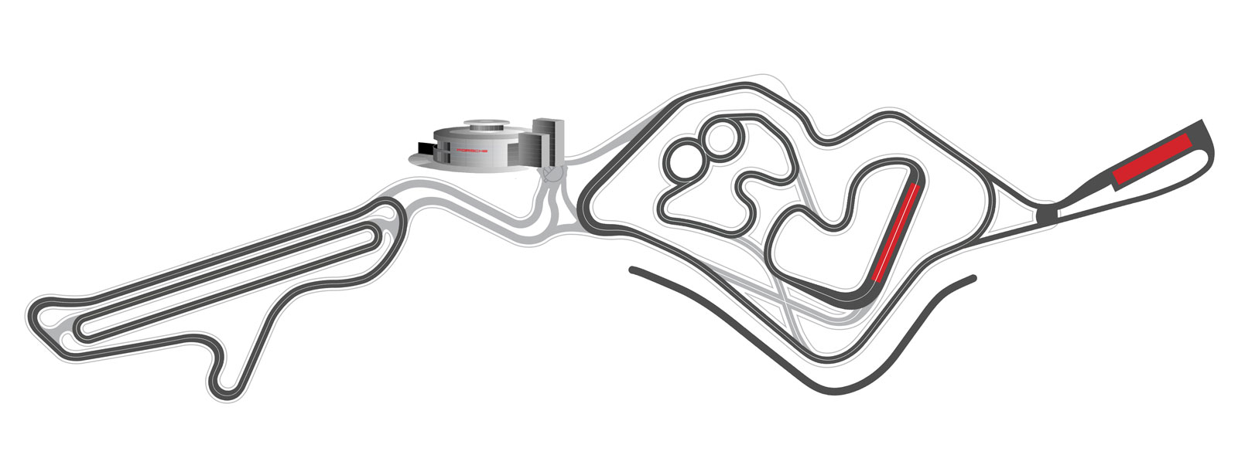

Further to a meeting with our very supportive Porsche Centre Principal Kevin Turner we have managed to secure

6 x Porsche Driving Experiences at The Silverstone Porsche Experience Centre.

These will be raffled as 6 individual prizes in this draw and all proceeds will go to our chosen charity Little Bridge House,

Children’s Hospice South West.

Tickets will be sold at future events and can also be bought by sending an email to – [R15@porscheclubgb.com](mailto:R15@porscheclubgb.com)

**Tickets are £5 Each**

**The draw will be made at our National Trust Visit on**

**Sunday 14th September**