Notes taken from the Officials conference 22nd April and the AGM 23rd April 2017

Conference Notes

There are now 17550 members, increased from 16900 beginning of year. The retention is now at 86% which is very good.
Newly appointed regions organisers and register secretaries were welcomed to the club.

The Porsche club GB is now recognised as the best Porsche club in the world.
There are various projects on book, one is the car sales rollout just about to begin. Porsche cars GB approve vehicles will also have input to this. I understand there will be a fee of between £5 and £10 to place an advert.

There are plans to upgrade certain parts of the club house, this is presently being looked at.

Finance.

The income from 2016 was £1429.2K, up from £1222.2K in 2015
Porsche cars GB have increased their support from 100K from 75K IN 2015. With the increase, Porsche cars GB are expecting the club to be professionally present the brand at various events where Porsche cars GB might not be present

For 2017 the revenue is already up by 15% from the first quarter of last year.

Chris Seaward Clubhouse general manager.

Club in great position
We are challenged to carry the foundations we have forward
Very proud of the commitment of the staff at the club
We have two large National events for this year, the Silverstone classic 30th July and Ragley Hall National Concours event.

Notes from the clubs Strategy director

Partnerships
- Long term partnerships delivering valuable benefits to the Club and members
- To add to the value of members’
experiences, the provision of insight and the sense of community

Advice
- We are the first place a member goes for knowledge and advice
- To provide members the most
comprehensive technical information and advice available in the UK on all Porsche models

Community
 To increase a feeling of belonging or sense of personal connection
 To create an environment where members feel the Club meets their needs and they are rewarded for their participation

Experiences
- To offer exclusive and unique
experiences to our members
- A be a vibrant and responsive club that satisfies the needs and wants of each section of it’s membership

Strategy in action

Partnership
- Porsche provided exclusive member benefits at PEC during Silverstone WEC
- Porsche provided venue and Paris Dakar 959 for evening with Jacky Ickx
- Archant filmed ‘evening with’, 996 technical seminar and Brands Hatch track evening
Advice
- Buyers’ guides professionally written and available online and in Porsche Post
- 996 Technical seminar held at the Clubhouse and hosted by recognized model experts and filmed to make the connect available to all
Community
- Clubhouse on the road bringing your Clubhouse to you and a place where you are welcomed and feel at home
- Communication pre and post event communications reinforcing the sense of community and belonging
Experience
- Evenings with Porsche motorsport legends unique and exclusive to Club members
- Memorable award winning events that stand out as being more than just an event
- Outlaw to Black Tie wide range of events and events appealing for all interests

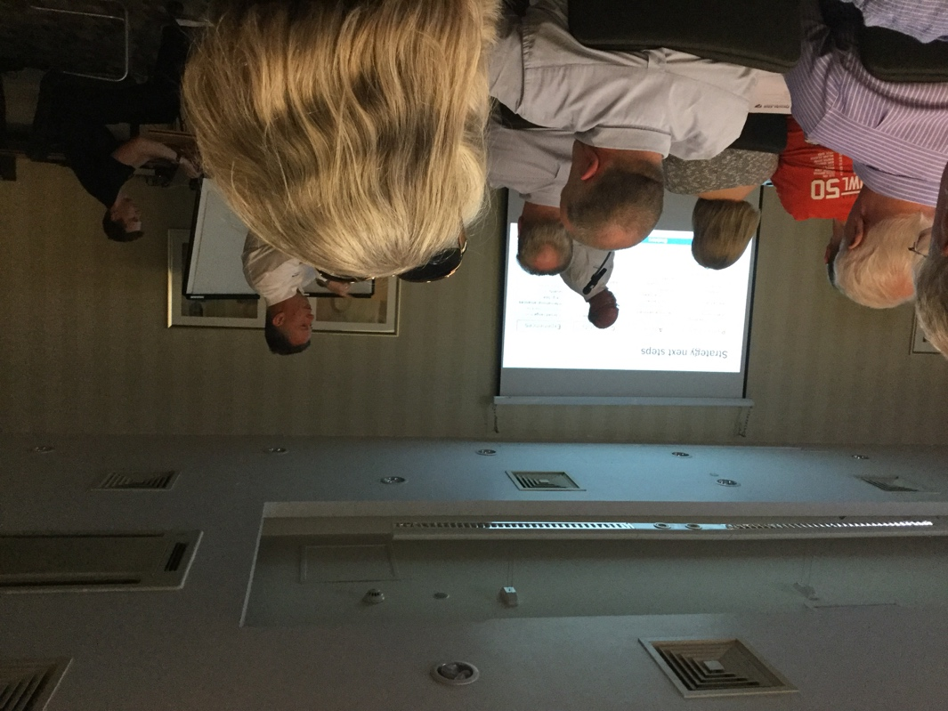
Presentation at the Officials conference.

AGM 23rd April

Phil Graham was elected to be the new region director.
Ian Yeoman was re appointed the financial director.
Nick Pyke was re elected to be the communications and Strategy director.

I was surprised, from a membership number of 17750 members, only 360 members returned their votes.

