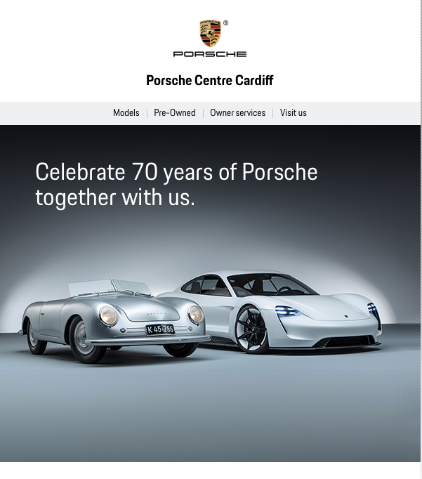

Some things don’t change. The dream of a perfect sports car drove Ferry Porsche to create the very first Porsche on 8 June 1948, and that dream is alive and well today 70 years on.
In June this year, to celebrate the 70th birthday of Porsche, our Porsche Centre will be holding a Sportscar Together Day. You, your family and your friends are invited to Porsche Centre Cardiff on Saturday 9 June 2018 between 10am and 5pm to help celebrate this historic occasion.
The event is a celebration of all things Porsche, bringing together Porsche drivers and fans, along with a display of both classic and new Porsche models, plus fun for the whole family.
We will be displaying our full current model range and a number of classic Porsche models through the ages. For entertainment there will be F1 virtual reality racing simulators, workshop tours and mini Direct Dialogue Bay sessions, a kid’s driving school and indoor climbing wall, plus offerings from local businesses including Indian head massage and facials. We will be offering hot breakfast rolls, hog roast, ice creams and barista coffee throughout the day. Demonstration drives will be available, but must be pre-booked so please contact us using the details below to make an appointment.*

