November Run – Stonehaven to Glenesk (40 miles)
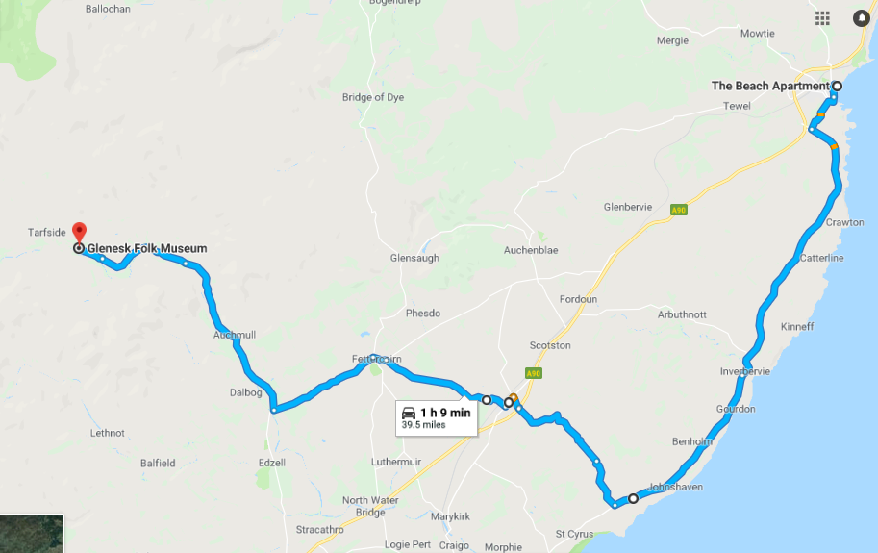

Glenesk Folk Museum – The Retreat, Glenesk, Brechin, DD9 7YT
The folk museum is nestled deep into the hills along the path of the River North Esk. Owned by the Glenesk Trust and run by a lively team of volunteers, the museum is free to enter and hosts a wonderful array of domestic and agricultural artefacts. The original retreat, now demolished, was a cottage built by Captain Wemyss in the 1840s as an escape from the sea – once you catch a glimpse of the views you’ll understand why.
Join us in Stonehaven at the Beach Promenade to journey along the coast (A92), over the Hill of Garvock to our unique destination. Food will be available at the museum, along with a gift shop with local makes. If the weather permits, there is a lovely walk to Loch Lee further down the road which offers some spectacular views.

Mileage | Directions | Comments
0 | The Beach Promenade, Stonehaven AB39 2RD | Meet at the Beach Promenade at 10.15am
0.1 mi | Head north-east towards Beach rd
144ft | Turn left onto Beach Rd
0.1mi | Turn left onto B979
0.4 mi | Continue onto Allardice St/A957 | continue to follow A957
1.3 mi | Turn left onto A92
8.8 mi | Slight left onto Montrose Rd/A92 | continue to follow A92
5.8 mi | Turn right
1.6 mi | Continue onto B9120 | Hill of Garvock Road - Picturesque.
3.4 mi | Turn tight onto A90 | Take immediate left junction towards B9120 Laurencekirk
210 ft | Turn left at 1st cross street onto B9120 | continue to follow B9120
0.4 mi | Turn left onto High St/A937
0.4 mi | Turn right onto Blackiemuir Avenue/B9120 | continue to follow B9120
4.1 mi | Slight left onto B9120/B966
0.4 mi | At roundabout take 1st exit onto Main St/B966 | continue to follow B966
3.5 mi | Turn right following signposts to Glenesk
5.6 mi | Keep left
0.9 mi | Slight right
2.0 mi | Keep left
0.7 mi | Slight right | Folk museum will be on the right. Optional – continue onto Loch Lee carpark for photo opportunities before returning to the museum.

