No | Mileage | Tulip | Description
1 |  |  | Zero trip at the roundabout ( Give Way Lines) upon exit from carpark
2 |  |  | 4th exit onto Pencarn way
3 | 0.3 | 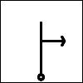 | SP M4 Newport at the lights. Get into middle lane and join M4 Eastbound.
4 | 3.7 |  | M4 Jct 26 offslip A4051 Malpas Road
5 | 5.4 | 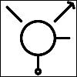 | 2ND exit SP Llantarnam
6 | 6.2 |  | SP Abergavenny A 4042
7 | 6.5 |  | SP Abergavenny A 4042

No | Mileage | Tulip | Description
8 | 6.8 |  | SP Abergavenny A4042
9 | 7.6 |  | SP Abergavenny/Pontypool A 4042
10 | 8.9 |  | SP Pontypool A472
11 | 10.0 |  | SP Pontypool A4042
12 | 10.9 |  | SP Pontypool A472 Big Pit/Pwll Mawr
13 | 11.9 | 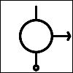 | SP Blaenavon A4043
14 | 12.1 |  | SP Blaenavon A4043

No | Mileage | Tulip | Description
15 | 12.6 |  | 1st Exit
16 | 17.9 |  | 1st Exit left down the hill B4246
17 | 18.0 | 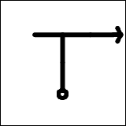 | SP Abergavenny B4246  Right turn up hill
18 | 18.4 | 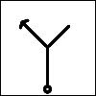 | Slow, Care, Left Into Estate Road  BIG BROWN SIGN for BIG PIT
19 | 18.5 | 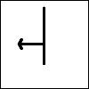 | Immediately Left again Into Gilchrist Thomas Industrial Estate  Carry on until reaching Rhymney Beer bridge.
20 | 19.2 |  | Turn Immediately into Big Pit car Park  Please Park all together in Coach Park
Car park cost £3 Tour- no charge-takes 1 hour and cannot be pre-booked. If you do not wish to go underground you are free to visit all the other displays etc.
There is also a café available.

No | Mileage | Tulip | Description
 |  |  | RESET YOUR TRIP MILEOMETER at second junction SP Heritage town.
 |  |  | On leaving the Coach park turn right
1 | 0.1 | 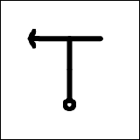 | SP Heritage Town
2 | 0.7 |  | SP B4426 Abergavenny
3 | 0.8 |  | SP B4426 Abergavenny
4 | 5.0 |  | Govilion
5 | 6.1 | 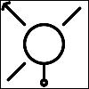 | SP A4077 Crickhowell/Gilwern  Under By-Pass
6 | 7.2 | 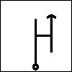 | SP A4077 Crickhowell  Care Junction just after pub. Easy to miss.

No | Mileage | Tulip | Description
7 | 10.4 | 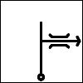 | Over single lane bridge to Crickhowell  A4077 Keep left at fork.
8 | 10.8 |  | SP A40 Brecon. Shell garage straight ahead on junction.
9 | 12.4 |  | SP A479/A470 Builth Wells
10 | 22.7 |  | 2nd Exit Builth Wells
11 | 23.1 |  | SP A4078 Three Cocks
12 | 25.2 |  | SP A438 Hereford
13 | 27.0 |  | Continue on B4350 Hay on Wye

No | Mileage | Tulip | Description
14 | 30.7 |  | S.p Redwardine/ Peterchurch 300m T right into Oxford Car Park. Pay and display 70p/HR  Opposite Car Park entrance is a small alley next to Tourist Office. This takes you past a few small shops and onto main street. Have a Stop at Eve’s for a cuppa.
 |  |  | Meet back in Car Park in 1 HR
1 |  |  | Reset Road Trip.  Turn right on leaving car park
2 | 2.5 |  | SP Ross B4348  Peterchurch.
3 | 14.8 |  | SP Ross B4348
4 | 18 | 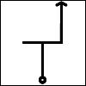 | Shell garage on left.  Turn right and immediately turn left B4348
5 | 18.5 |  | Slow +Care -Level crossing

No | Mileage | Tulip | Description
6 | 21.8 |  | SP B4348 Ross On Wye  Monmouth A466
7 | 21.9 | 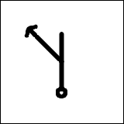 | SP B4348 Ross on Wye
8 | 24.0 |  | SP A49 Ross On Wye
9 | 25.9 | 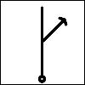 | SP Symonds Yat / Monmouth A4137
10 | 30.4 |  | SP Monmouth A40 / Symonds Yat
11 | 30.6 | 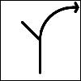 | SP A40 Monmouth  Join main dual carriageway and head for Monmouth.
12 | 34.8 | 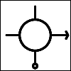 | At Roundabout take 3rd exit A 466 Monmouth. Drive through Monmouth Town. Keep going down main street 90 left bend toT jct/Mini Roundabout 2nd exit over bridge until traffic lights.

No | Mileage | Tulip | Description
13 | 36.1 |  | At Traffic lights T right heading for Rockfield.
14 | 38.1 |  | Keep on B4233
15 | 40.5 |  | Entrance into Rolls Monmouth Golf club  We have allocated parking in the courtyard before taking afternoon tea overlooking the course.

