Porsche Club GB- R14: Lakes, Reservoirs and Mountains Number 2.
Sunday drive. October 14th 2018
Junction.  number | Total cumulative distance.(approx.) | Tulip diagram/ direction arrow. | Additional route information.
1 | Note: Zero your trip meter at the park gates. | 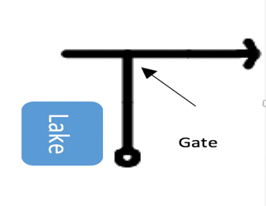 | Exit Cyfarthfa Park via the North Gate and turn right up the hill.
2 | 0.2 | 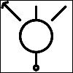 | Take the first exit on the roundabout.
3 | 1.5 | 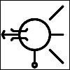 | Take the first exit on the roundabout, cross over the bridge & go straight on.
4 | 2.1 | 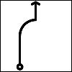 | Pass a cemetery on your left hand side.
5 | 2.2 | 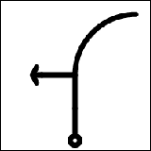 | Turn left at the junction.  Signpost Ponsticill -  2.2 miles & also a sign for a railway
6 | 2.2 |  | Pass a pub on your right hand side (Y Pant Cad Ifor)
Junction number | Total cumulative distance. (approx.) | Tulip diagram / direction arrow. | Additional route information.
7 | 2.5 | 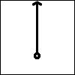 | Pass the Brecon Mountain Railway on your right hand side.
8 | 3.2 | 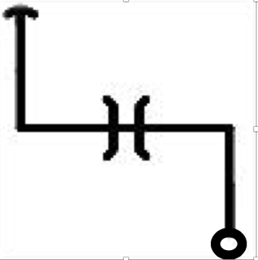 | Turn left underneath a bridge and then immediately right.
9 | 3.6 | 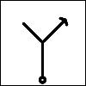 | Fork right at junction.
10 | 4.0 | 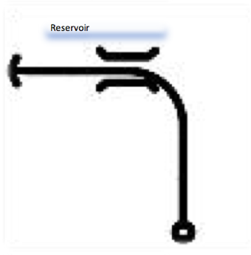 | Road turns left onto reservoir dam wall.
11 | 4.2 | 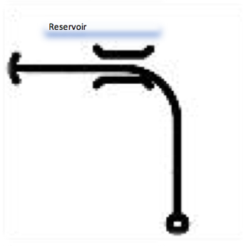 | Stop at the end of the dam wall for a photo opportunity/ view the reservoir.
12 | 4.4 | 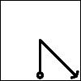 | Hairpin right turn.  Signpost: Talybont on Usk - 10 miles.
13 | 6.2 | 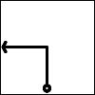 | Turn left at junction. Signpost: Talybont on Usk - 8 miles.
14 | 7.2 | 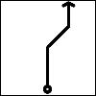 | Turn right at junction. Signpost: Aber - 6.5 miles & Talybont on Usk -7.5 miles.
15 | 8.4 | Park on right hand side of road | Halt at lay by to re-group.
 | 8.6 to 8.8 | Slow down!!!!! Drive with caution ahead. | Take care, tight hairpin bends over blind crest
16 | 11.2 | 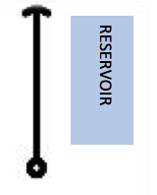 | Pass Talybont reservoir on your right hand side.
17 | 14.3 | 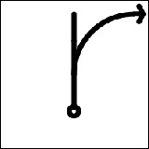 | Junction, follow road to the right. Signpost: Talybont on Usk
18 | 14.7 | 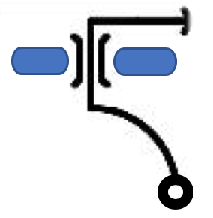 | Drive over canal bridge and at junction turn right. Signpost: Llangynidr- 4 miles
19 | 14.9 | Star Inn | Sign post:Llangynidr-4 miles. Crickhowell-8.5 miles.  Pass the White Heart Inn.
Junction number | Total cumulative distance (approx.) | Tulip diagram / direction arrow. | Additional route information.
20 | 15.0 | 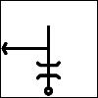 | Drive underneath a bridge & at junction turn left. Signpost: A40 Brecon.
21 | 15.8 | 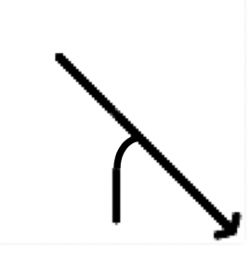 | At junction turn right onto A40.  Signpost: Abergavenny- 14 miles.
22 | 17.6 | 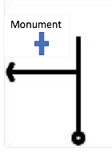 | At junction turn left onto B4560 towards Llangorse
23 | 20.5 |  | Pass café on right hand side. (WC available)
24 | 21.4 | 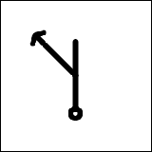 | Pass Castle Inn & Red Lion Pub & at junction turn left to Llangorse Lake.
25 | 21.5 | 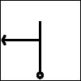 | At junction turn left to Llangorse Lake,
Junction number | Total cumulative distance. (approx.) | Note: Please reset you trip meter to zero for the second half of the drive | Reset you trip meter adjacent to the café.
26 | 21.8 | Park up adjacent to the café.  Post Code: LD3 7TR | 60 minute rest / coffee break & photo opportunity.
27 | 0.3 | 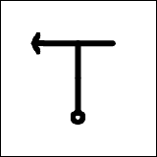 | At junction turn left. Signpost: Brecon.  Drive past the Black Cock Inn on your right hand side
28 | 3.9 |  | At junction turn left. Signpost: Brecon -2.5 miles.
29 | 4.2 | 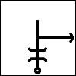  A40 | Drive under bridge and at junction turn right. Signpost: Brecon -2 miles.
30 | 4.2 | 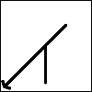  A40 | At junction turn left onto A40. Signpost: Brecon -2 miles.
31 | 4.9 |  | At the roundabout take the first exit onto the Brecon bypass.  A470 towards Merthyr & Cardiff.
Junction number | Total cumulative distance. (approx.) | Tulip diagram / direction arrow | Additional route information.
32 | 7.2 | 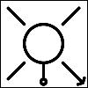 | At the roundabout take the fourth exit B4061 towards Brecon / Llanfaes.
33 | 8.2 | 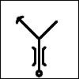 | Drive over the bridge River Usk to traffic lights and take the second left (Through traffic)
34 | 8.4 | 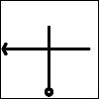  B4520 | At the second set of traffic lights turn left onto the B4520  Through traffic
35 | 8.5 |  | At the traffic lights turn left. Signpost: Upper Chapel 8.5 miles
36 | 13.2 |  | .  Drive through the village of Lower Chapel. (B4520)
37 | 17.2 |  | Drive through the village of Upper Chapel. (B4520)
Junction number | Total cumulative distance. (approx.) | Tulip diagram / direction arrow | Additional route information.
38 | 17.8 | 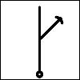  B4520 | Follow the road to the right at the junction and continue on the B4520 towards Builth Wells.
39 | 21.3 | 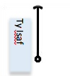 | Ty Isaf sign on the left hand side.
40 | 24.4 | 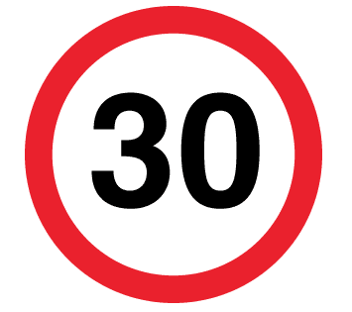 | Enter Builth Wells. 30 mph sign.
41 | 24.8 | 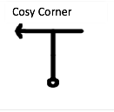 | At junction turn left.
42 | 24.9 |  | At junction take the right hand lane towards Llandrindod Wells.
43 | 25.0 | 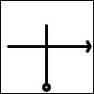 | At crossroads turn right. Signpost: Thro traffic.
Junction number | Total cumulative distance. (approx.) | Tulip diagram / direction arrow | Additional route information.
44 | 25.1 | 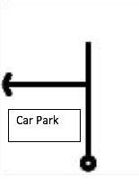 | Turn left into the car park. Re-group/ toilet.
45 | 25.1 | 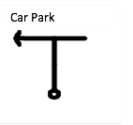 | Exit the car park and turn left.
46 | 25.2 | 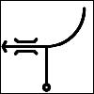  WYE | At junction turn left over the bridge. A470.
47 | 25.5 | 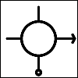  A470 | At the roundabout take the third exit. Sign post Llandrindod Wells. A483
48 | 26.0 | 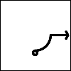  A481 | At the junction turn right. Sign post New Radnor 13 miles / Hundred House 5 miles.
Junction number | Total cumulative distance. (approx.) | Tulip diagram / direction arrow | Additional route information.
49 | 26.5 | A44 | At the roundabout take the 2nd exit towards New Radnor. (A44)
50 | 26.8 | 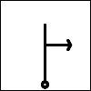  B4567 | At junction turn right towards Aberedw.(B4567).
51 | 27.4 | Crest In Road | Slow and caution blind crest !!!!
52 | 29.2 | 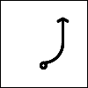 | Caution tight bends through houses !!!
53 | 32.0 | 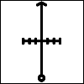  Cattle Grid | Drive over the cattle grid and caution - sheep maybe in the road.
54 | 32.7 | 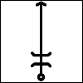 | Follow the road to the right. Drive under the bridge.
Junction number | Total cumulative distance. (approx.) | Tulip diagram / direction arrow | Additional route information.
55 | 33.0 | 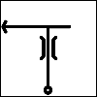 | Drive over the bridge to the junction and turn left onto the A470. Sign post Brecon.
56 | 36.2 |  | Turn left into Llangoed Hall for lunch
 |  |  | Well done you can now have a drink and a bite to eat.
Start Post Code: CF47 8PA.
Cyfarthfa Park Museum.

Halfway rest halt Post Code:
LD3 7TR – Café at Llangorse Lake
.
Finish Post Code: LD3 0YP. Llangoed Hall Hotel.

Contact numbers:
Paul Bowyer
07738 185332
Brian Jones.
07740 461739 &
07391 177456
Huw Jones.
07799 532661.

